

Software Quality Engineering (SQE)

Assignment 2_Deliverable 1

Group Information

Name: M.Mustagees Shahid (24P-3052)
Name: Malik Aleem Ahmad (24P-3076)
Name: Hunain Zahid (24P-3085)

Section: SE-5B

White Box Testing

1. Scope and Approach:
This document covers the assigned white-box analysis of registration_decision(): CFG, Cyclomatic Complexity, independent basis paths, Condition Coverage and MC/DC. Expected behavior is derived from the assignment SRS/REQUIREMENTS.md, not assumed from the implementation.
CFG scope: only the body of registration_decision() is included. Calls to prerequisites_satisfied() and check_credit_limit() are treated as single predicate evaluations; their internal decisions are not expanded. The compound capacity validation is expanded into three atomic conditions to show Python short-circuit behavior.

2. Control Flow Graph (CFG):
The diagram expands the capacity validation into A, B and C. A False result at A skips B; if the left side of the OR is already True, C is also skipped.
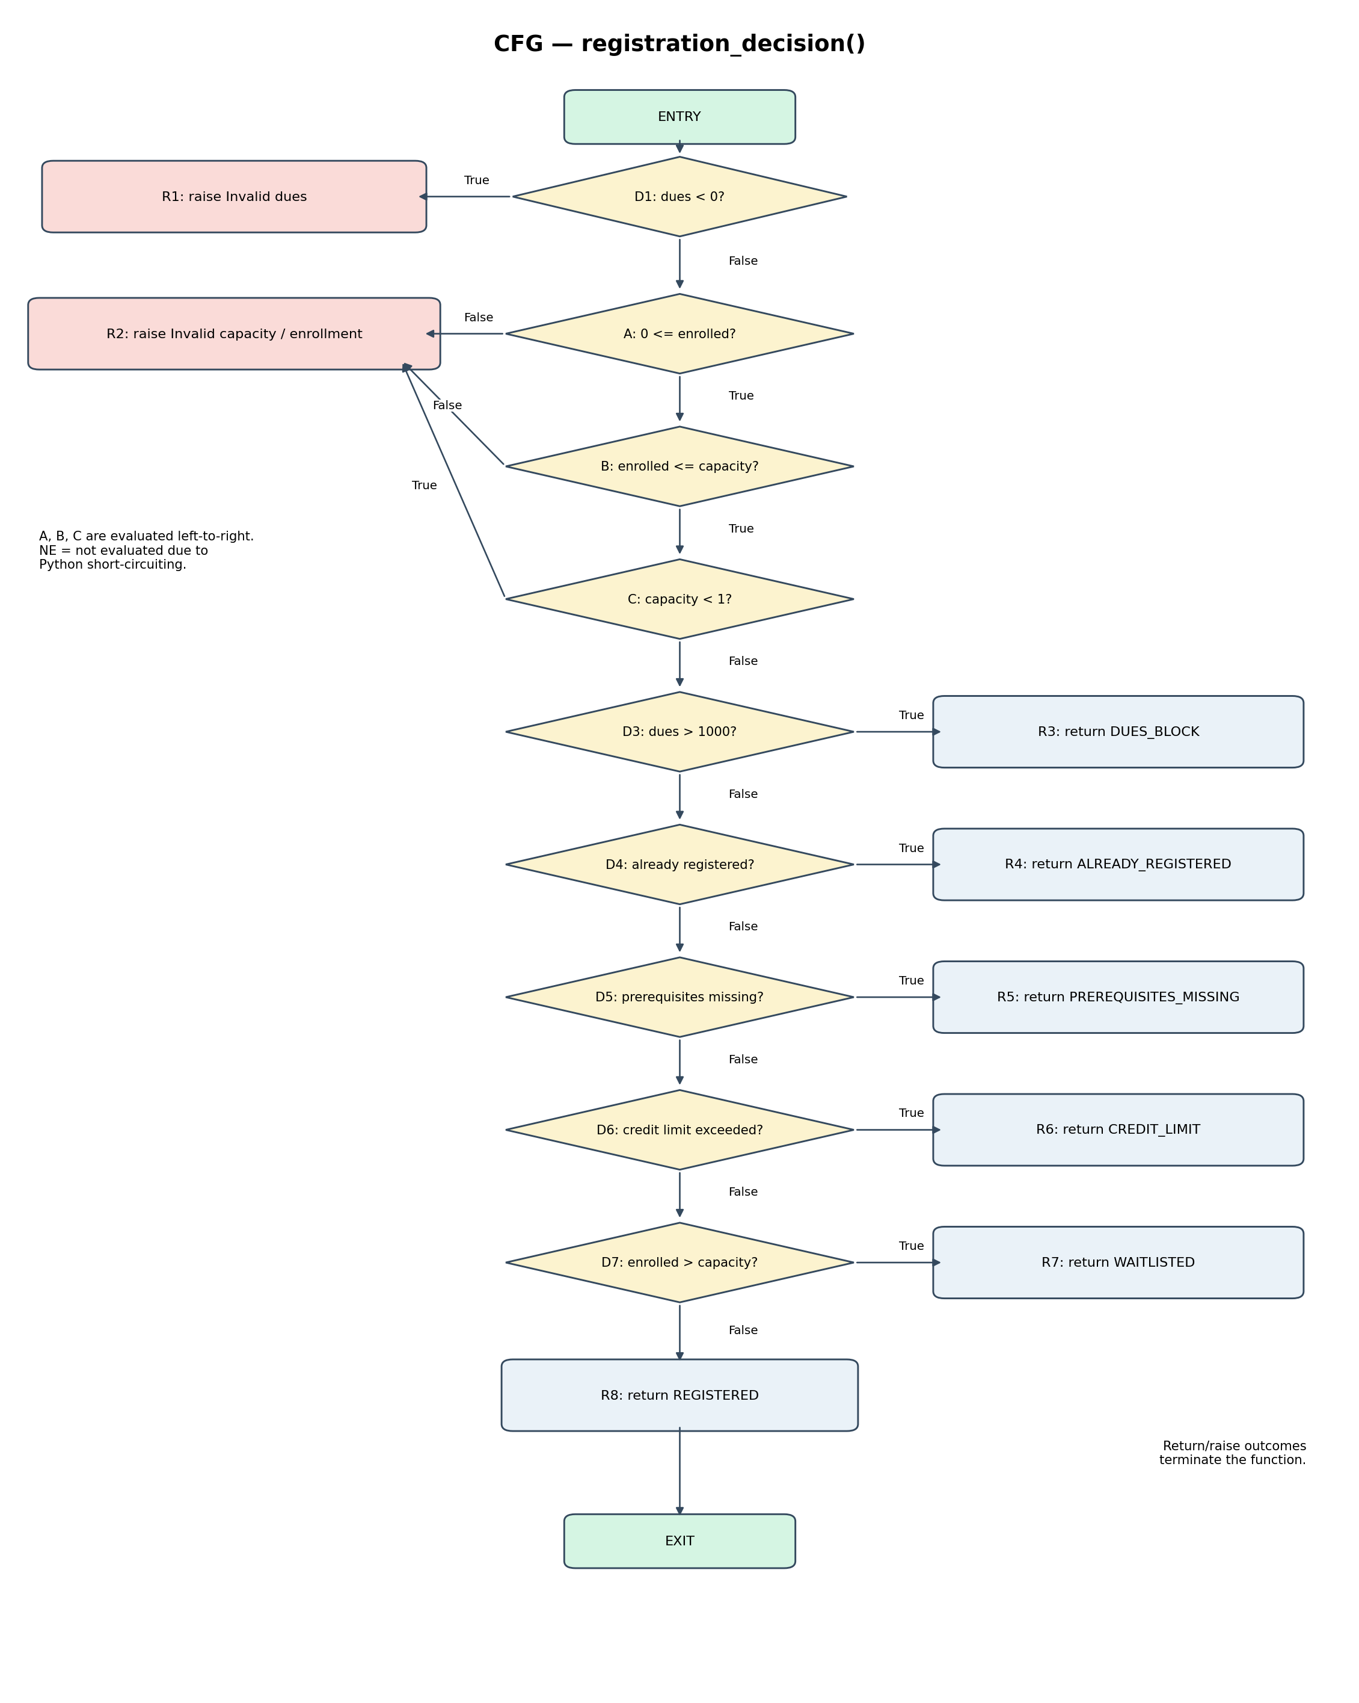

2.1 Node labels:
Node | Meaning
ENTRY | Start of registration_decision().
D1 | outstanding_dues < 0
A | 0 <= course.enrolled
B | course.enrolled <= course.capacity
C | course.capacity < 1
D3 | outstanding_dues > 1000
D4 | course.code is already registered
D5 | prerequisites are missing
D6 | credit limit is exceeded
D7 | course.enrolled > course.capacity
R1–R8 | Raise or return outcomes shown in the CFG.
EXIT | Function termination.

3. Cyclomatic Complexity:
Counting convention: A, B and C are counted as three atomic decision nodes because the compound validation uses short-circuit evaluation. Along with D1 and D3–D7, the CFG has 9 decision nodes.
Formula: V(G) = E − N + 2

Measure | Count | Explanation
N — Nodes | 19 | ENTRY + 9 decision nodes + 8 terminal outcome nodes + EXIT.
E — Edges | 27 | 18 decision edges + 1 entry edge + 8 terminal-to-exit edges.
V(G) | 27 − 19 + 2 = 10 | Cyclomatic Complexity.

Cross-check: decision nodes + 1 = 9 + 1 = 10. This matches E − N + 2. The result uses the stated expanded short-circuit convention consistently. For the E − N + 2 calculation, each return/raise outcome is treated as connecting to one conceptual common EXIT node; those terminal-to-EXIT links are omitted from the drawing to keep it readable.

4. Independent Basis Paths and Test Mapping:
With V(G) = 10, the CFG has 10 independent basis paths. The mapping below distinguishes existing tests from suggested representative inputs that are not currently in the test file.
Path | Decision sequence / outcome | Representative test or input | Status / note
P1 | D1=True → Invalid dues exception | test_negative_dues_raise_error(); dues=-1 | Existing; exercises path.
P2 | D1=False, A=False → invalid capacity | Parameterized invalid-capacity case: enrolled=-1, capacity=10 | Existing case.
P3 | D1=False, A=True, B=False → invalid capacity | Parameterized case: enrolled=11, capacity=10 | Existing case.
P4 | D1=False, A=True, B=True, C=True → invalid capacity | Parameterized case: enrolled=0, capacity=0 | Existing case.
P5 | Validation passes, D3=True → DUES_BLOCK | Suggested input: dues=1001, otherwise valid | Current test uses dues=1; it exposes the SRS defect but does not take the implementation's >1000 branch.
P6 | D3=False, D4=True → ALREADY_REGISTERED | test_already_registered_course_is_blocked() | Existing; exercises path.
P7 | D3=False, D4=False, D5=True → PREREQUISITES_MISSING | Suggested input: completed_courses=set(), required={'CS101'} | Current partial-prerequisite test exposes a defect but implementation returns True for any intersection.
P8 | Earlier checks False, D6=True → CREDIT_LIMIT | test_total_credits_above_18_are_rejected(); current=16, new=3 | Existing; exercises path.
P9 | Earlier checks False, D7=True → WAITLISTED | No feasible input in supplied function | Unreachable: earlier validation rejects enrolled > capacity.
P10 | All earlier checks False, D7=False → REGISTERED | test_course_with_available_seats_is_registered() or test_valid_course_capacity_does_not_raise_error() | Existing; exercises final path.

Note: P5 and P7 show suggested inputs because the current test file does not directly execute those implementation branches. P9 is structurally present but infeasible because the earlier validation rejects enrolled > capacity. Do not claim that an existing test executes a branch when the code actually takes another path.

5. Condition Coverage and MC/DC:
Selected compound decision:
if not 0 <= course.enrolled <= course.capacity or course.capacity < 1:
Atomic conditions:
- A = 0 <= course.enrolled
- B = course.enrolled <= course.capacity
- C = course.capacity < 1
The invalid-input decision is True when (not A) OR (not B) OR C. Python evaluates the chained comparison from left to right. If A is False, B is not evaluated. If the left side of the OR is already True, C is not evaluated.

5.1 Truth table from existing test inputs:
Case | enrolled | capacity | A | B | C | Invalid decision | Test location
TC1 | -1 | 10 | F | NE | NE | True | Parameterized invalid-capacity test
TC2 | 5 | 10 | T | T | F | False | test_valid_course_capacity_does_not_raise_error()
TC3 | 11 | 10 | T | F | NE | True | Parameterized invalid-capacity test
TC4 | 0 | 0 | T | T | T | True | Parameterized invalid-capacity test

F=False, T=True, NE=Not Evaluated at runtime. TC1 skips B and C because A is False and the OR decision is already True. TC3 skips C because the chained comparison is False, making the left side of the OR True.

5.2 Condition Coverage:
Condition | True demonstrated by | False demonstrated by | Result
A | TC2, TC3, TC4 | TC1 | Both outcomes covered
B | TC2, TC4 | TC3 | Both outcomes covered
C | TC4 | TC2 | Both outcomes covered

The existing inputs demonstrate True and False outcomes for each atomic condition. NE entries are retained to show actual runtime short-circuit behavior.

5.3 MC/DC independent effect pairs:
Condition | Test pair | Condition change | Decision change | Explanation
A | TC1 vs TC2 | A: F → T | True → False | B is logically True in both inputs and C logically False in both. In TC1, B and C are skipped at runtime; explain this as masking MC/DC.
B | TC2 vs TC3 | B: T → F | False → True | A remains True; C is logically False in both inputs (capacity=10), although C is skipped in TC3.
C | TC2 vs TC4 | C: F → T | False → True | A and B remain True; only C changes.

These pairs show the independent effect of A, B and C on the overall decision. For A and B, logical values are distinguished from runtime evaluation because Python may skip a condition. The A pair is explained using masking MC/DC.

6. Findings from the Supplied Implementation:
- Dues: implementation checks outstanding_dues > 1000, but the SRS says any positive amount must block registration.
- Prerequisites: implementation accepts any intersection; the SRS requires every prerequisite to be completed.
- Credit limit: implementation uses a strict less-than check; the SRS allows exactly 18 total credits.
- Availability: validation rejects enrolled > capacity, so the later WAITLISTED condition enrolled > capacity cannot be reached. The SRS says enrolled == capacity should waitlist.
- Withdrawal: implementation does not decrement course.enrolled, although the SRS requires this update.
These are implementation-versus-requirement observations. The assignment instructs students not to modify the implementation during initial test design/execution; defects should be tracked and fixed later through the team's workflow.

7. Test Execution Results:
The white-box test cases were executed using pytest to evaluate the supplied implementation against the requirements defined in the SRS.
7.1 Overall Test Results:
Test Result | Number of Tests
Passed | 13
Failed | 6
Total | 19

6.2 Failed Test Cases:
The following six test cases failed during execution:
Test Case | Expected Result | Actual Result
test_any_positive_dues_block_registration | Registration should be blocked for any positive dues. | Registration was allowed.
test_registration_blocked_when_one_prerequisite_is_missing | Registration should be blocked if any prerequisite is missing. | Registration was allowed.
test_total_credits_equal_to_18_are_allowed | Registration should be allowed when total credits equal 18. | CREDIT_LIMIT was returned.
test_full_course_student_is_waitlisted | Student should be added to the waitlist when the course is full. | REGISTERED was returned.
test_waitlisted_student_is_added_only_once | Student should be added to the waitlist only once. | A ValueError was raised on the second attempt.
test_withdraw_registered_course_updates_records | Course enrollment count should decrease after withdrawal. | Enrollment count remained unchanged.

6.3 Analysis:
The test execution showed that 13 tests passed and 6 tests failed. The failed tests indicate differences between the supplied implementation and the expected SRS requirements.
These failures were recorded as implementation defects. The implementation was not modified during the initial test execution, so the results reflect the behavior of the original supplied code.

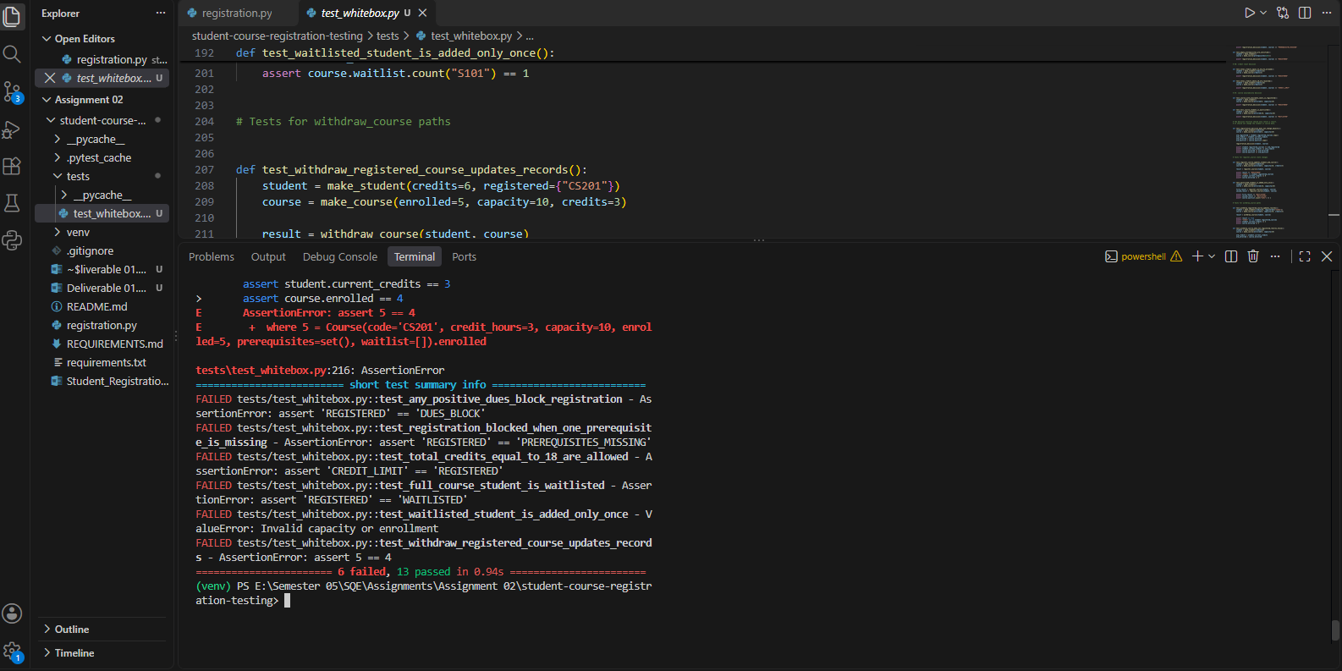

8. Conclusion:
Using the expanded short-circuit convention, the CFG has 19 nodes and 27 edges, producing V(G)=10. The basis-path analysis identifies ten independent paths, including a structurally unreachable WAITLISTED branch in the supplied implementation. The existing test inputs cover True and False outcomes for A, B and C, and the listed MC/DC pairs show each condition's independent effect while documenting short-circuit cases.

